

Tine Alpha

Programmer's manual
Dominik Salvet
January 2017

Contents
1 Characteristics of Tine Alpha 3
1.1 Memory model 3
1.2 Register file 3
1.3 List of instructions 3
1.4 Architecture schematic 4
1.5 Input and output 4
2 Instruction set 5
2.1 Used conventions 5
2.2 Instructions with immediate value 5
2.2.1 Arithmetic and logic 5
2.2.2 Loading constants 7
2.2.3 Unconditional jumps 7
2.3 Instructions working with registers 8
2.3.1 Arithmetic and logic 8
2.3.2 Register value transferring 10
2.3.3 Accessing the memory 10
2.3.4 Unconditional jumps 11
2.3.5 Conditional instruction skips 11
2.4 Program example 13
3 Instruction processing 14
3.1 Instruction stages 14
3.2 Pipeline stalls 14
List of Symbols and Abbreviations 15

Characteristics of Tine Alpha
Tine Alpha is processor architecture with the following characteristics:
- 8-bit width,
- Harvard type,
- MISC type,
- can address up to 256 B memory of each instructions and data,
- has instruction pipelining.

Memory model
For both instruction and data memory is used physically addressed flat model - every address used in instruction is equal to address that will appear on the address bus. The data memory address space includes I/O devices.

Register file
Architecture is accumulator-based and so defines one main register known as accumulator (A is short and symbolic variant), which is used in every instruction except JMP instruction. Also there are file of four registers, known as RF (next time it stands for one of these four registers), that are used as second operand of most instructions.

List of instructions
- ADD - addition
- SUB - subtraction
- SL - set if less
- SLU - set if less unsigned
- NOR - negation of logical disjunction
- AND - logical conjunction
- SLL - shift left logical
- SRL - shift right logical
- LI - load immediate value
- LIS - load immediate value scaled
- CPA - copy to accumulator
- CPR - copy to register
- LDA - load to accumulator
- STA - store accumulator
- JMP - jump
- JMPA - jump to accumulator
- JWL - jump with link
- JWLA - jump with link to accumulator
- SKNV - skip never
- SKIP - skip the following instruction
- SKE - skip if equal
- SKNE - skip if not equal
- SKL - skip if less
- SKLE - skip if less or equal
- SKG - skip if greater
- SKGE - skip if greater or equal

Architecture schematic
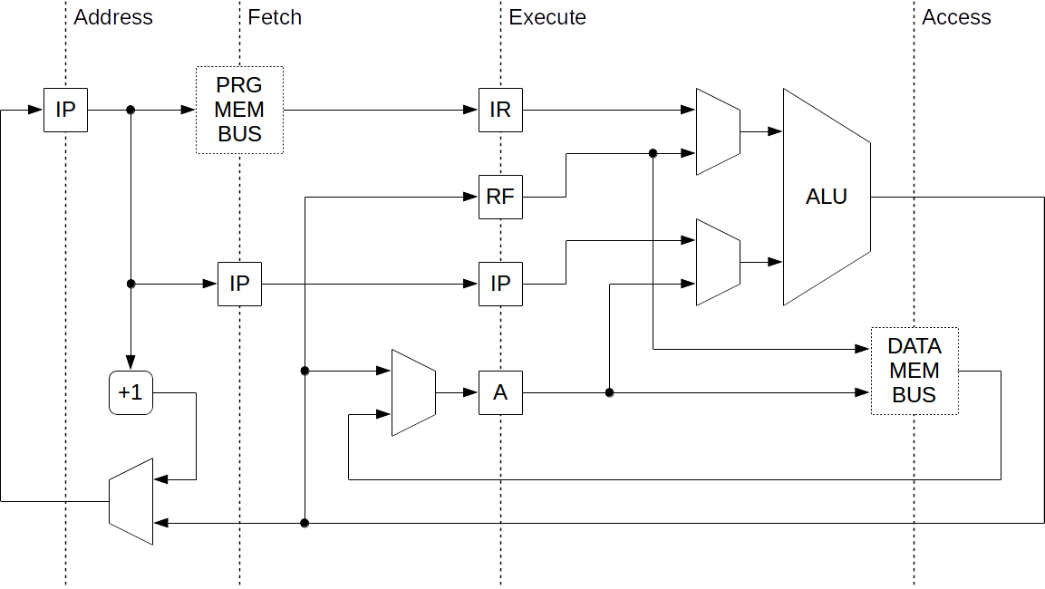

Input and output
CLK | in | clock signal source
RST | in | reset signal
IMEM_IN[8] | in | instruction memory read data
IMEM_RD | out | instruction memory read enable
IMEM_ADDR[8] | out | instruction memory address
DMEM_IN[8] | in | data memory read data
DMEM_WR | out | data memory write enable
DMEM_ADDR[8] | out | data memory address
DMEM_OUT[8] | out | data memory written data

Instruction set
This chapter contains description of every executable instruction. Every description of instruction is explaining dependencies of instruction word and its final binary form as well as behavior of individual instructions. Every instruction lasts one clock signal, unless otherwise stated.

Used conventions
The following labels addr4, imm4, uimm4 that will be used later, are representing any natural number in the range:
- addr4 - from -2³ to 2³ - 1,
- imm4 - from -2³ to 2³ - 1,
- uimm4 - from 0 to 2⁴ - 1.
These numbers can be expressed in various radix:
- Decimal - <digits(0-9)> or <digits(0-9)>D or <digits(0-9)>d:
  - it is possible to demonstrate the value sign, even if it is positive,
- Hexadecimal - <digits(0-F or 0-f)>H or <digits(0-F or 0-f)>h,
- Octal - <digits(0-7)>O or <digits(0-7)>o,
- Binary - <digits(0,1)>B or <digits(0,1)>b.

Instructions with immediate value
This type of instructions is using 4-bit immediate value contained inside its instruction word as a operand. This value is always extended to 8-bit width before enter ALU. So the immediate value can be interpreted as follows:
- signed value (always two’s complement format):
  - addr4, imm4,
- unsigned value (always direct binary value):
  - uimm4.

Arithmetic and logic
The most common instructions that perform arithmetic and logic computing. The first operand is always A register, also the result of operation is always written here. The second operand is largely 4-bit signed value. Note that logic operations don’t make the difference, logic operations always execute on signed extended value. The only exception that is using unsigned value of immediate value is SLU instruction.
Instruction word structure

List of instructions

Description of instructions
AND imm4
- Performs bitwise logical conjunction between A register and 4-bit signed value extended to 8-bit width, the result is written to A register.
NOR imm4
- Performs logical negation of bitwise logical disjunction between A register and 4-bit signed value extended to 8-bit width, the result is written to A register.
SLL imm4
- Performs logical shift to the left of value in A register by unsigned value of 3 lower bits of 4-bit immediate value operand, the result is written to A register.
SRL imm4
- Performs logical shift to the right of value in A register by unsigned value of 3 lower bits of 4-bit immediate value operand, the result is written to A register.
SLU uimm4
- Performs value compare of unsigned arithmetics with 4-bit unsigned value and A register. If A register value is less, LSB of A register is set and other bits are cleared. Otherwise, all bits of A register are cleared.
SL imm4
- Performs value compare of signed arithmetics with extended 4-bit signed value and A register. If A register value is less, LSB of A register is set and other bits are cleared. Otherwise, all bits of A register are cleared.
SUB imm4
- Performs arithmetic subtraction of 4-bit signed value from A register, the result is written to A register.
ADD imm4
- Performs arithmetic addition of 4-bit signed value and A register, the result is written to A register.

Loading constants
Instructions that load 4-bit unsigned values to A register. There are two mods for that. The first one loads 4-bit binary string from instruction word to lower part of A and clears the higher. The second, scaled mode, loads 4-bit binary string to higher part of A and clears the lower.
Instruction word structure

List of instructions

Description of instructions
LI uimm4
- Loads immediate value to A register. 4-bit unsigned value is 4-bit lower part and it is extended by 4-bit higher part of zeros. These parts are composed together and written to A register.
LIS uimm4
- Loads scaled immediate value to A register. 4-bit lower part is containing zeros and 4-bit higher part is represented by 4-bit unsigned value. These parts are composed together and written to A register.

Unconditional jumps
Unconditional jumps instructions provide a way to change address of executed instructions. It can be also linked the address of instruction that follows jump instruction. This can be used for calling functions. Immediate value is interpreted as signed value that represents address displacement from address of currently executing jump instruction.
Instruction word structure

List of instructions

Description of instructions
JWL imm4
- Performs unconditional jump to change the following instruction’s address. The final address is calculated by adding address of actual instruction (IP register value) and signed 4-bit value. Since the immediate value is signed, it is also possible to perform jump backwards, as it is required. The following instruction’s address (IP + 1) is written to A register.
- This instruction lasts 3 clock signals to perform.
JMP imm4
- Performs unconditional jump to change the following instruction’s address. The final address is calculated by adding address of actual instruction (IP register value) and signed 4-bit value. Since the immediate value is signed, it is also possible to perform jump backwards, as it is required.
- This instruction lasts 3 clock signals to perform.

Instructions working with registers
This type of instructions is using only registers to achieve the result.

Arithmetic and logic
The most common instructions that perform arithmetic and logic computing. The first operand is always A register, also the result of operation is always written here. The second operand is RF register.
Instruction word structure

List of instructions

Description of instructions
AND Ri
- Performs bitwise logical conjunction between A register and RF register, the result is written to A register.
NOR Ri
- Performs logical negation of bitwise logical disjunction between A register and RF register, the result is written to A register.
SLL Ri
- Performs logical shift to the left of A register by value of 3 lower bits of RF register, the result is written to A register.
SRL Ri
- Performs logical shift to the right of A register by value of 3 lower bits of RF register, the result is written to A register.
SLU Ri
- Performs value compare of unsigned arithmetics between A register and RF register. If A register value is less, LSB of A register is set and other bits are cleared. Otherwise, all bits of A register are cleared.
SL Ri
- Performs value compare of signed arithmetics between A register and RF register. If A register value is less, LSB of A register is set and other bits are cleared. Otherwise, all bits of A register are cleared.
SUB Ri
- Performs arithmetic subtraction of RF register from A register, the result is written to A register.
ADD Ri
- Performs arithmetic addition of RF register and A register, the result is written to A register.

Register value transferring
The instructions that provide to move register values between themselves. The transfer can be realized only by using A register.
Instruction word structure

List of instructions

Description of instructions
CPA Ri
- Copies the value of RF register to A register.
CPR Ri
- Copies the value of A register to RF register.

Accessing the memory
The only way to communicate with the memory and I/O devices. RF register is always used as a pointer to the memory. When storing value, A register is holding the value that will be written to memory. When loading value, read value will be written to A register.
Instruction word structure

List of instructions

Description of instructions
LDA Ri
- Load value from memory pointed by RF register to A register.
- This instruction lasts 2 clock signals to perform.
STA Ri
- Store value of A register to memory pointed by RF register.

Unconditional jumps
Unconditional jumps instructions provide a way to change address of executed instructions. It can be also linked the address of instruction that follows jump instruction. This can be used for calling functions. Jump will be performed to address pointed by value in A register.
Instruction word structure

List of instructions

Description of instructions
JWLA
- Performs unconditional jump to address pointed by A register value. Also the following instruction’s address (IP + 1) is written to A register.
- This instruction lasts 3 clock signals to perform.
JMPA
- Performs unconditional jump to address pointed by A register value.
- This instruction lasts 3 clock signals to perform.

Conditional instruction skips
Conditional instruction skips provide the only way to achieve conditional program execution. There are several arithmetic conditions to provide conditional instruction skip. These conditions are always testing the A register value compared to zero and if condition is met, the following instruction will not be executed. Also there is SKNV instruction that can represent no operation instruction.
Instruction word structure

List of instructions

Description of instructions
All following instructions last 2 clock signals to perform if they successfully skipped the following instruction, otherwise 1 clock signal is required to complete.
SKNV
- Never skips the following instruction. It can represents no operation.
SKIP
- Skips the following instruction.
SKNE
- Skips the following instruction if A register value is not zero.
SKE
- Skips the following instruction if A register value is zero.
SKL
- Skips the following instruction if A register value is less than zero.
SKLE
- Skips the following instruction if A register value is less than zero or zero.
SKG
- Skips the following instruction if A register value is greater than zero.
SKGE
- Skips the following instruction if A register value is greater than zero or zero.

Program example
; == Unsigned software multiply ==
; perform multiply of unsigned numbers
; R1 = R2 * R3

;address mnemonic binary comment

00H: LI 13 01101101
01H: CPR R3 00011111 ; load R3 with 13
02H: LI 7 01100111
03H: CPR R2 00011110 ; load R2 with 7
04H: LI 0 01100000
05H: CPR R1 00011101 ; load R1 with 0

06H: CPA R2 00011010
07H: SKNE 00000010 ; test if R2 is 0
08H: JMP +5 01010101 ; if so, calculation complete (1)

09H: SLL 7 10100111 ; else
0AH: SKNE 00000010 ; check if R2 is even
0BH: JMP +7 01010111 ; if so, skip addition (2)
0CH: JMP +3 01010011 ; else, jump to addition (3)

0DH: LIS 2 01110010 ; (1) load jump complete address
0EH: JMPA 00001111 ; jump to it

0FH: CPA R1 00011001 ; (3)
10H: ADD R3 00111111 ; add R1 and R3
11H: CPR R1 00011101 ; write back to R1

12H: CPA R3 00011011 ; (2)
13H: SLL 1 10100001 ; double R3
14H: CPR R3 00011111 ; write back
15H: CPA R2 00011010
16H: SRL 1 10110001 ; half of R2
17H: CPR R2 00011110 ; write back
18H: LI 6 01100110 ; load jump address to iterate
19H: JMPA 00001111 ; iterate

20H: JMP 0 01010000 ; calculation is complete
The program is only for demonstrate the possibilities. Used algorithm is not intended to be optimized.

Instruction processing
Each instruction takes four clock signals to perform and is overlapped with three others instructions. Then under ideal conditions every clock signal is completed one instruction. This instruction processing is known as pipelining.

Instruction stages
Every instruction must go through four stages of pipeline to be performed. This stages are pretty independent between themselves and so it is possible to process four instructions at the moment at most. These are the stages:
- ADDR - calculating the address of the following instruction,
- FTCH - fetching the instruction from instruction memory,
- EXEC - decoding and performing arithmetic and logic operations,
- ACCS - accessing to data memory.

Pipeline stalls
Some instructions can cause pipeline stalls. It means that it is not possible to perform them in one clock signal and it is required some additional handling. Pipelined instruction processing can negatively affect these instructions:
- Any jump instruction (3 clock signals to perform):
  - it is required to fetch new instruction from just calculated address and wait to fill up the pipeline,
- Load data from memory (2 clock signals to perform):
  - at the first it is required to write data’s address on data memory address bus and then it is required to fetch the data,
- Any skip instruction (1 or 2 clock signals to perform)
  - if skip is successful, the following instruction is is replaced with SKNV (no operation) and it is performed, then the real effect comes when it is fetched the next instruction.

List of Symbols and Abbreviations
MISC | Minimal Instruction Set Computer
I/O | Input/Output
A | Accumulator
RF | Register File
ALU | Arithmetic Logic Unit
LSB | Least Significant Bit
IP | Instruction Pointer

